Receiving with barcodes
Use the Barcode app on the scanner. Scan the GTIN first, then the serial number for each unit of that product, before you move on.
The first scan only selects the product. It does not add anything to inventory.

Which barcode to scan
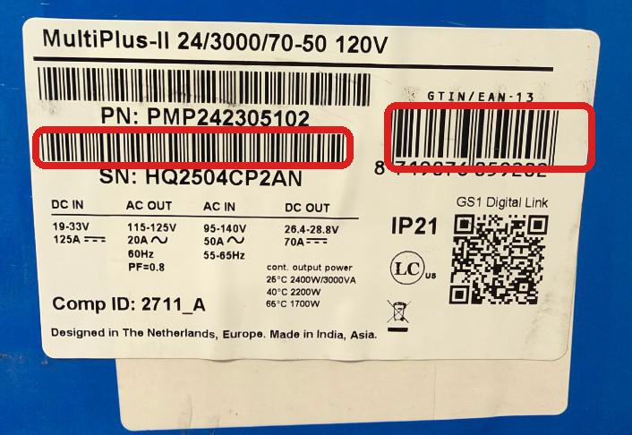
Scan the GTIN on the right, then the barcode under SN. Do not scan the PN barcode or the QR code.
Order | What to scan | On this label
First | GTIN / EAN-13. The barcode on the right. This is the product. | 8719076059202
Then, each unit | SN. The barcode under SN. This is that unit’s serial. | HQ2504CP2AN

Do not scan:
- The PN barcode, the long barcode under the product name. On this label that is PMP242305102.
- Either QR code. A QR scan is stored as the serial number.

1. Open the Barcode app
The scanner opens on this screen. Tap Operations.
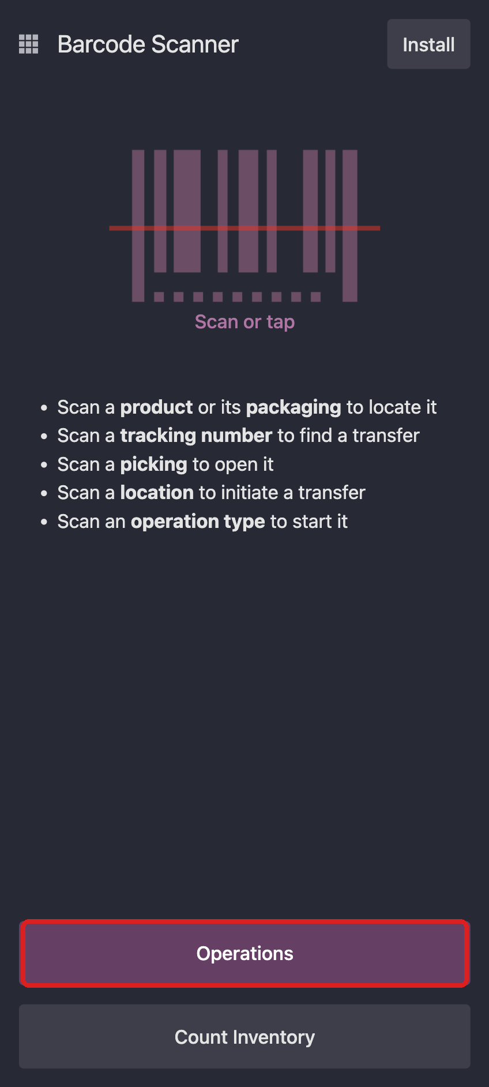
Barcode app home. Tap Operations.

2. Tap Receipts
On Operations, tap Receipts.
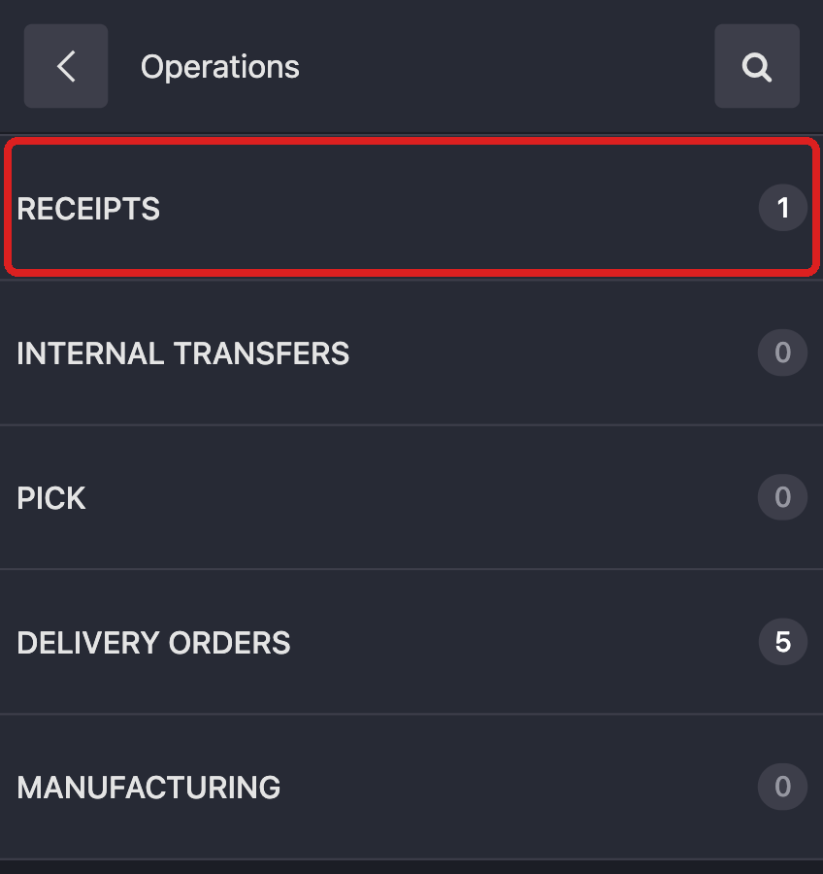
Operations. Receipts is the first row.

3. Open the receipt
You can scan a GTIN here to filter the list to receipts that contain that product. Open the one that is Ready.
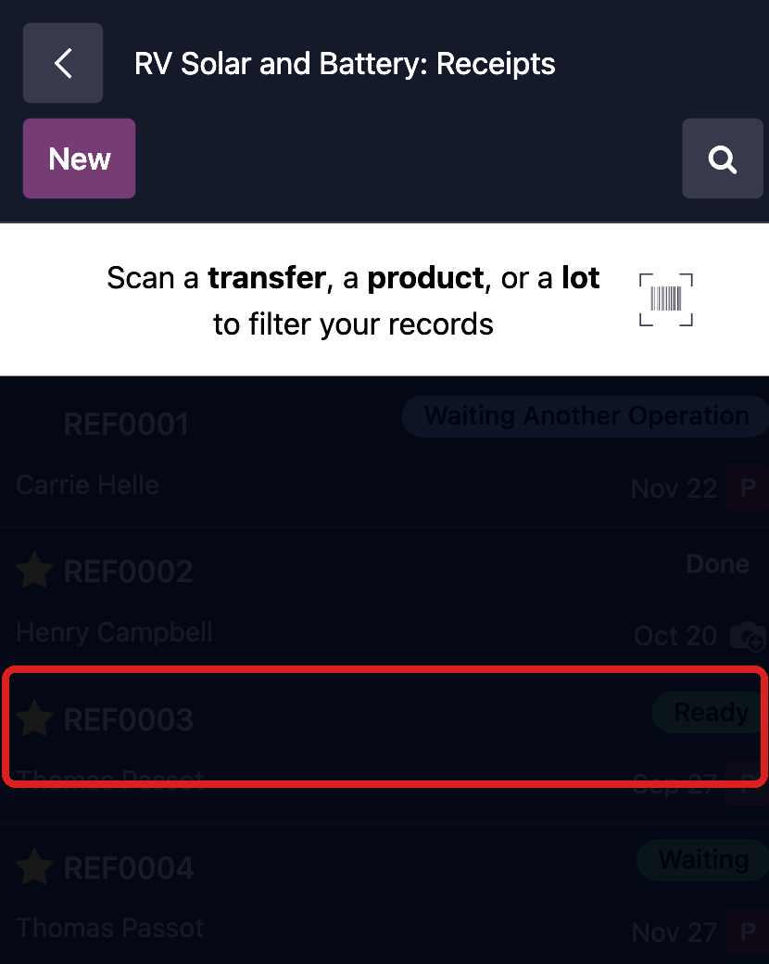
Receipts. Scan a product to filter, then open the Ready receipt.

4. The lines start at 0
The receipt opens with every line at 0. The bar at the top says Scan a product.
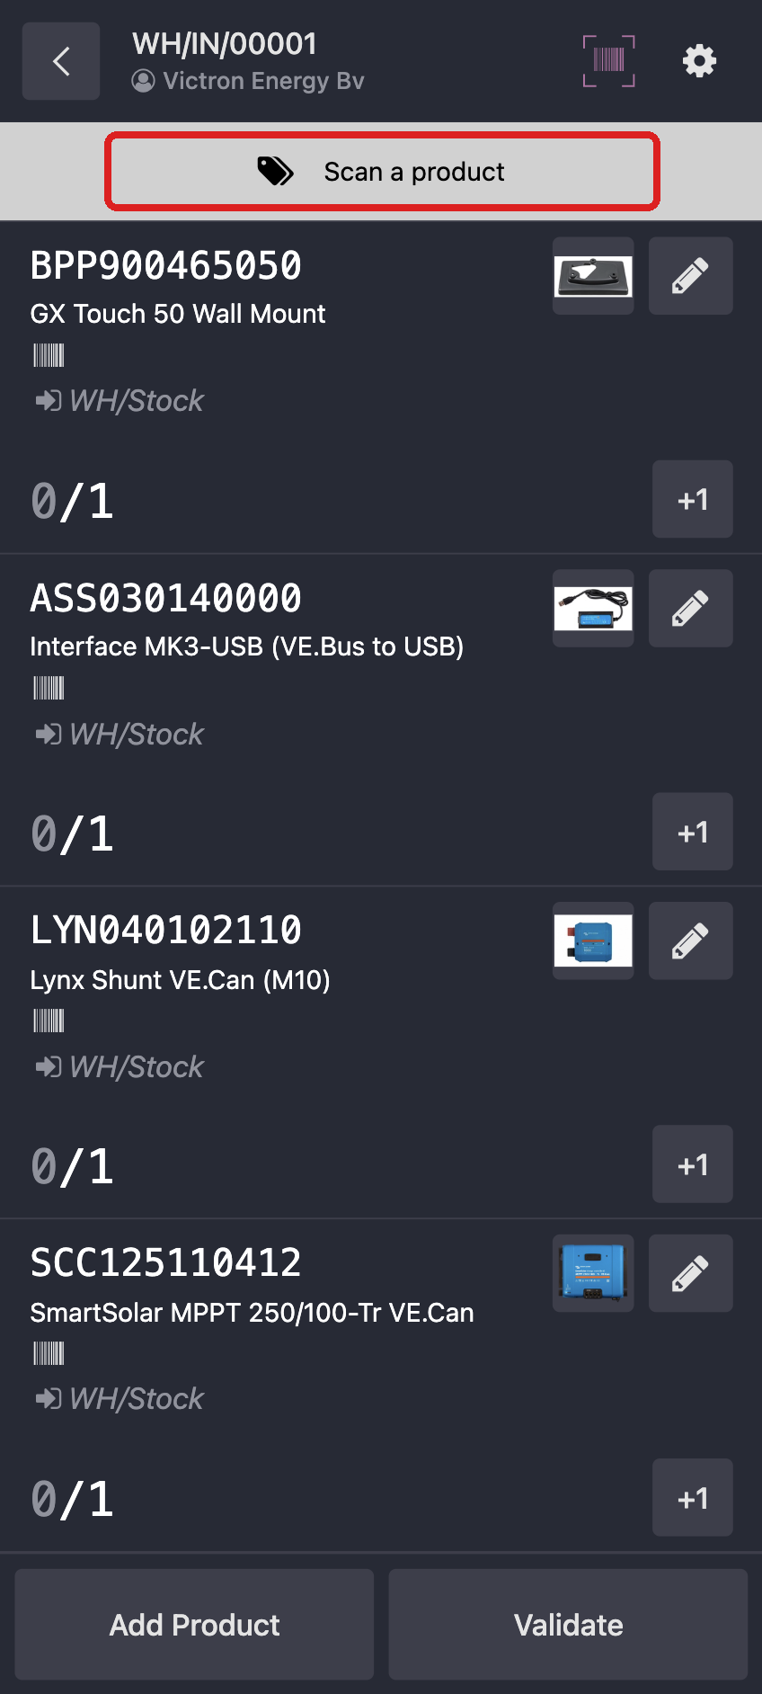
Nothing is received yet. Scan a product.

5. Scan the GTIN. The line turns blue
Scan the GTIN. The line gets a blue outline, and the bar says Scan a serial number. The count stays at 0. Nothing is in inventory yet.
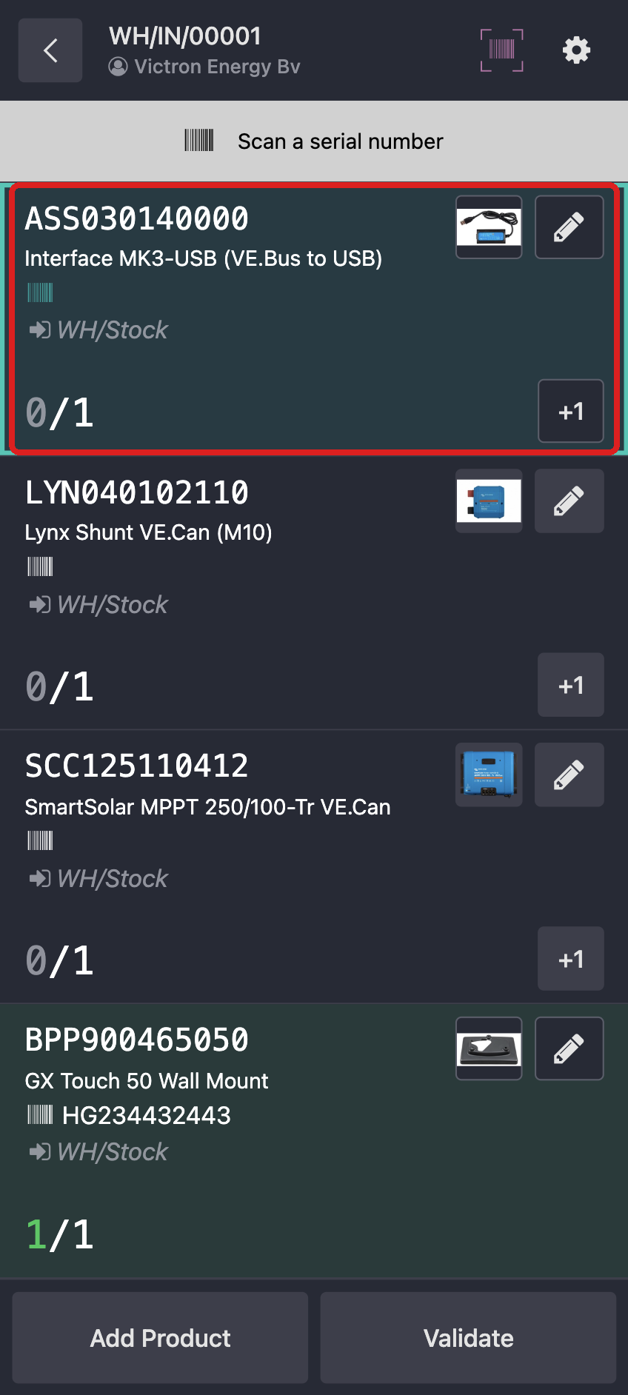
Blue outline after the GTIN. The count is still 0. Scan a serial number.

6. Scan each serial. The line turns green
Scan the SN once for each unit of this product before you move on. When the line has every unit, it turns green and shows 1/1. A −1 button appears. The bar goes back to Scan a product.
Validate stays grey while any line is still open.
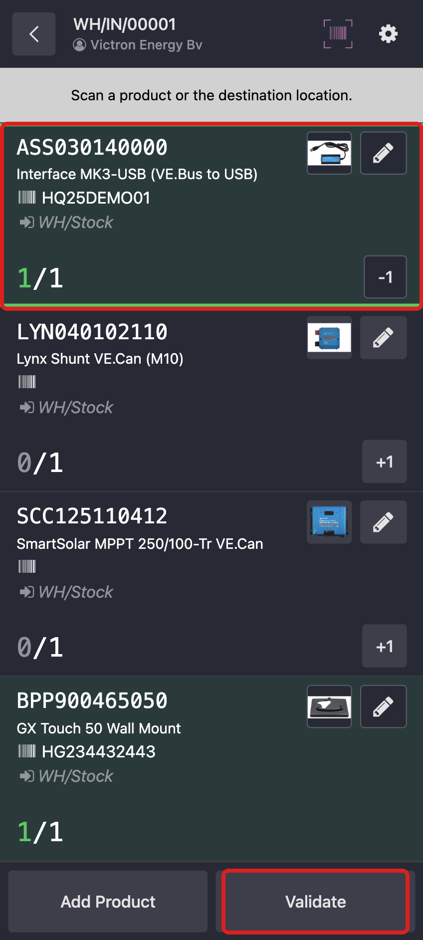
Green after the serial. Validate is still grey because other lines are open.
Then do the next product. Same order every time: GTIN, then each SN.
Wrong serial: tap −1 on that line. That removes the most recent serial only.

7. Validate turns purple when every line is green
Validate turns purple only when every line is green. That is the signal that the receipt is fully scanned. Tap Validate.
The receipt is then Done. Those units are on hand in the warehouse, under the serials you scanned.
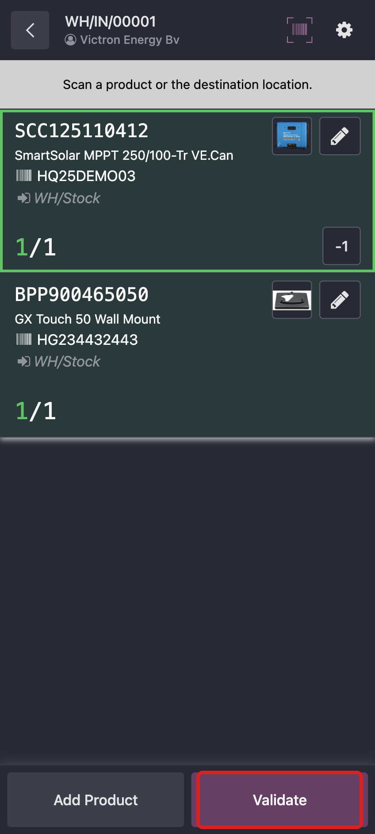
Every line is green, so Validate is purple.

Less than the receipt
If you tap Validate while a line is still short, the scanner opens Incomplete Transfer. The missing quantities are in red.
Tap Stay on transfer, then finish scanning. Tap Validate on that screen only when you mean to receive what is already scanned and put the rest on a backorder.
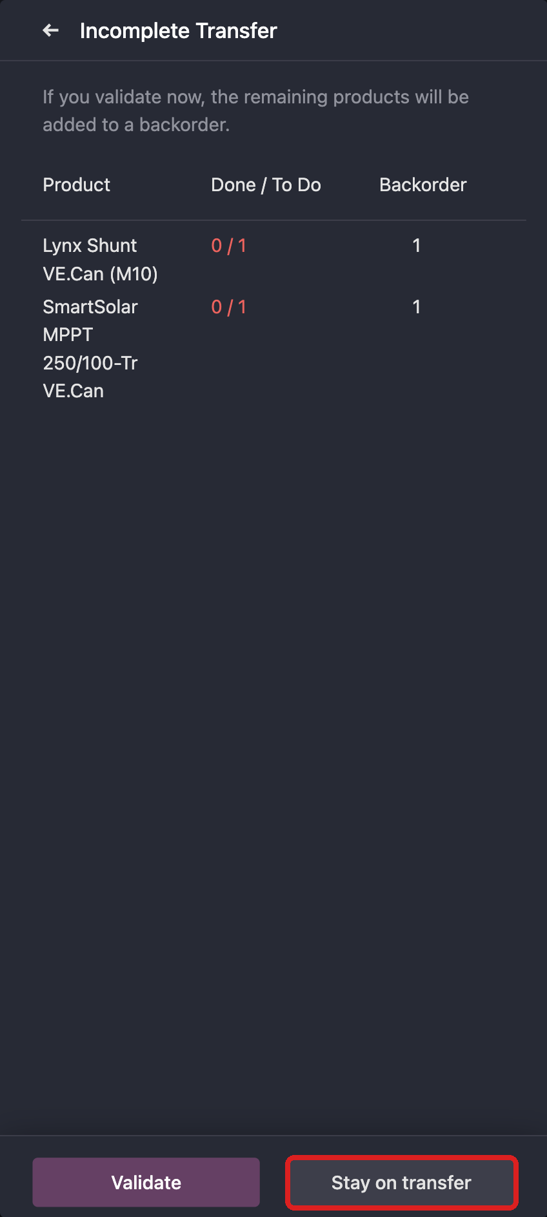
Short receipt. Stay on transfer unless you want a backorder.

More than the receipt
If a line says 2/1, you recorded more than the receipt asked for. The line does not turn green. Validate can still be purple, so read the count before you tap it.
Tap the pencil on that line and set the quantity back to the number on the receipt. Keep one serial for each unit you actually have. −1 takes one count off that line.
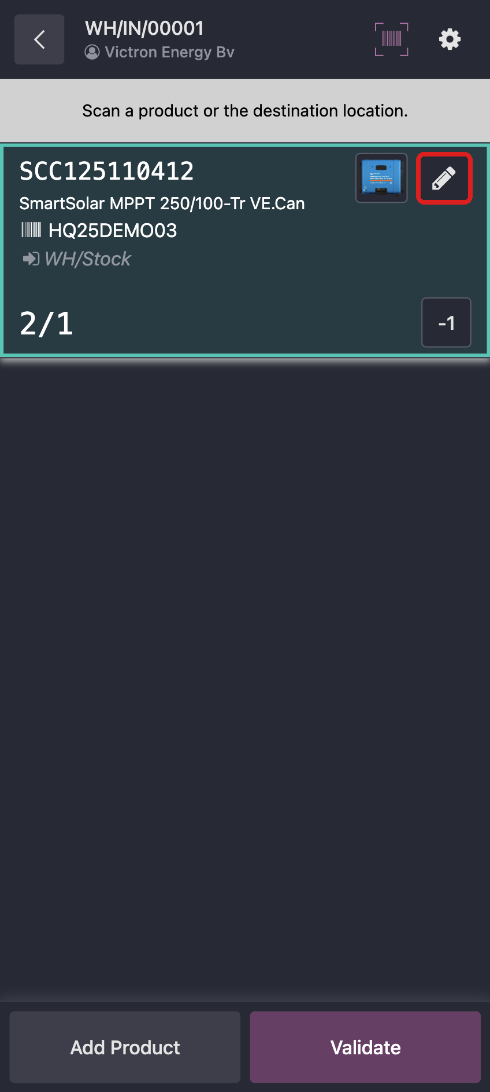
2/1 means one too many. Fix it with the pencil before you validate.

A product that is not on the receipt
Scanning a GTIN that is not on this receipt asks if you want to add it. Tap Cancel unless that product really belongs on this receipt.
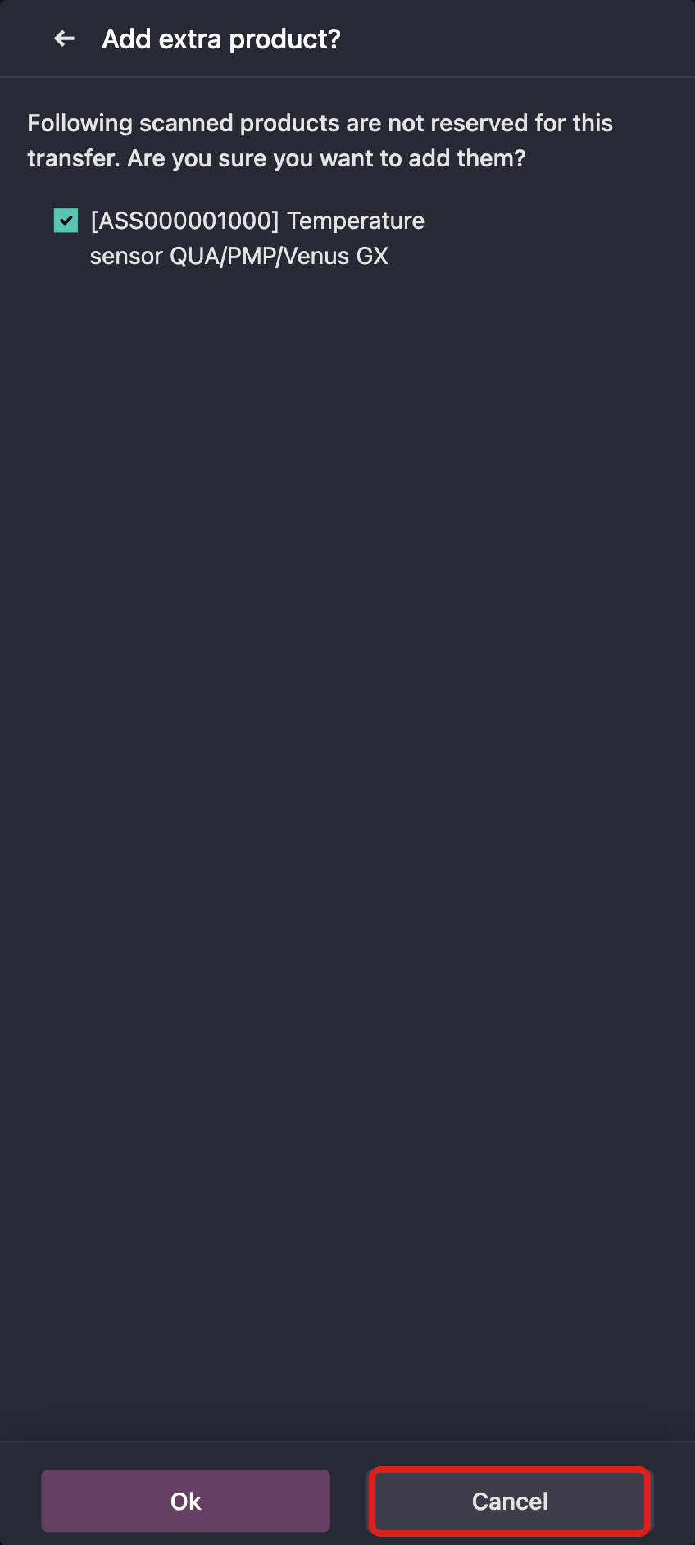
Unexpected product. Tap Cancel.

A barcode the system does not know
This product doesn’t exist. You scanned the PN, a QR code, or some other code. Scan the GTIN on the right of the label.
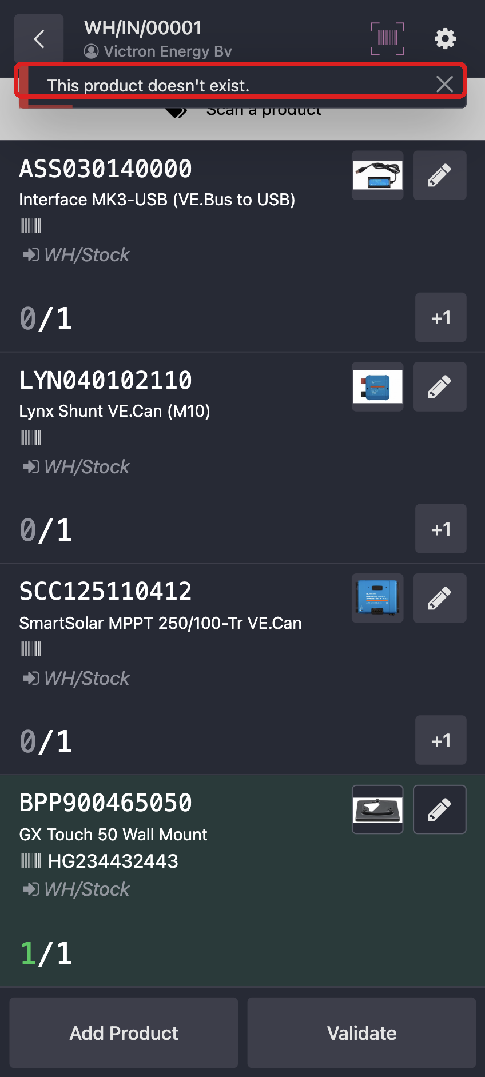
Unknown barcode. Scan the GTIN, not the PN or a QR code.

The same serial twice
The scanned serial number is already used. That serial is already on this receipt, so the line does not change. Scan the serial from the next unit.
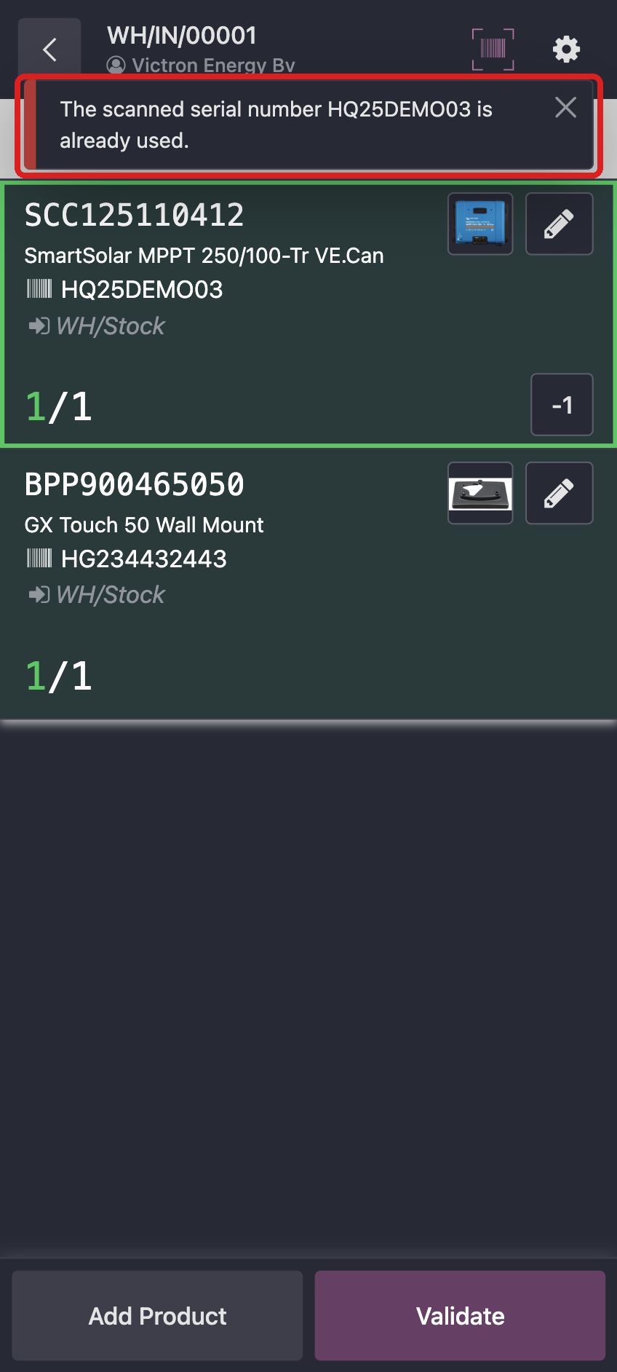
That serial is already on this receipt.

If the serial disappears
Scanning the GTIN again after the line is already green removes the serial. The count can look finished even though the serial is gone.
Scan the GTIN, then the serial, again. Do not go to the next product until the line is green and the serial is still on it.

